Let’s encrypt: https://www.digitalocean.com/community/tutorials/how-to-secure-apache-with-let-s-encrypt-on-centos-7

From httpd conf : sudo nano /etc/httpd/conf/httpd.conf

Virtual host ke requirements wise first er tar moto duplicate korte hobe, rewrite engine er line tuk lekha lagbe na, ota create hobe ssl engine set er por
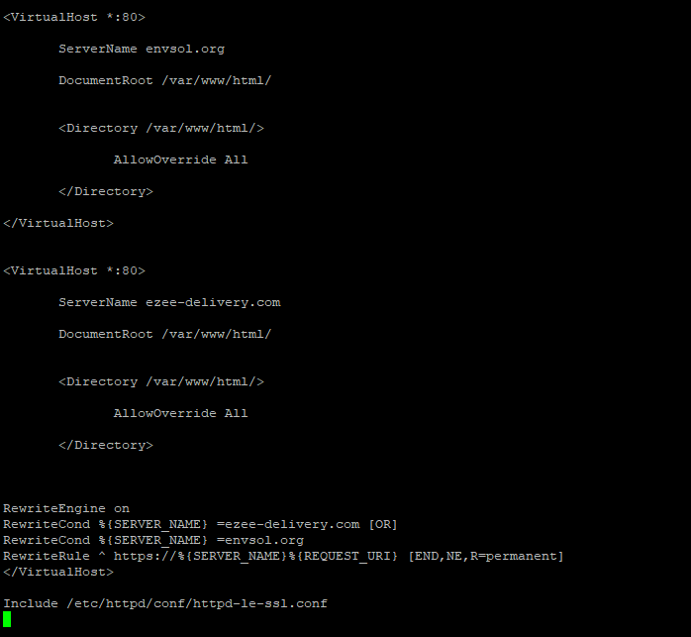

From ssl conf : sudo nano /etc/httpd/conf/httpd-le-ssl.conf
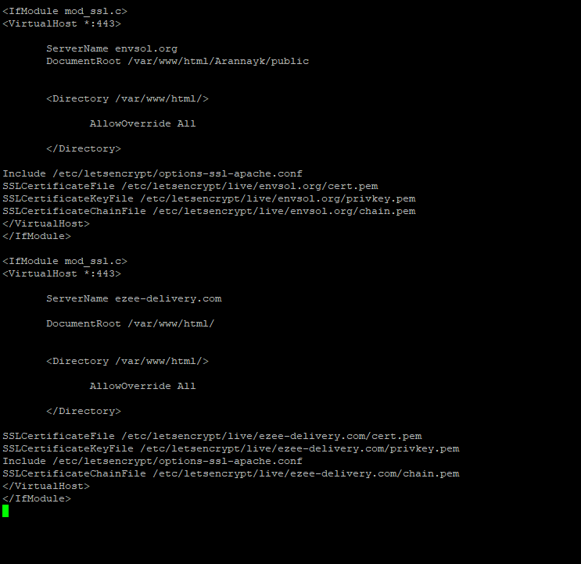

Ei line gula baad diye hobohu first tar moto copy korte hobe with desired domain name,
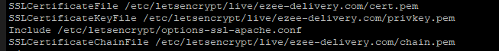
Then lets encrypt er command follow korte hobe from digitalocean

